**Figure S1.** Average ranges between JAL and MUL and standard error, plotted over frequency for focus participants who receive medication for their migraine and participants who do not.

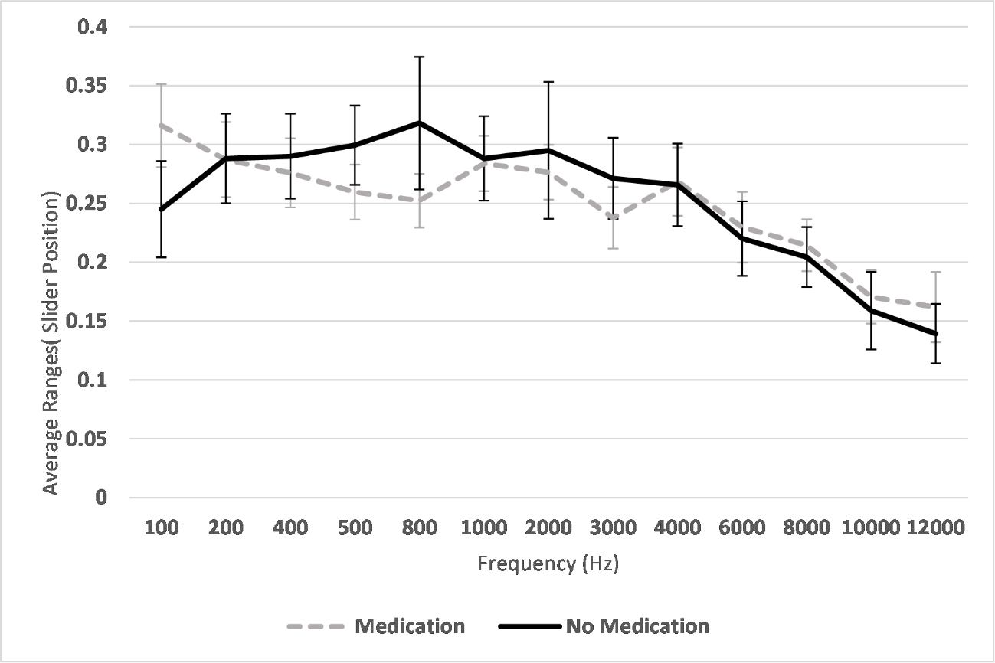

**Figure S2**. Average ranges between JAL and MUL and standard error, plotted over frequency for focus participants in the chronic and episodic migraine subgroups.

